What’s in our Food?
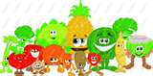
Objective: Compose a list of key nutrients, describe their functions and list food sources for each

Food | Vitamin or mineral that is in that food | What function does that vitamin or mineral do?
Whole milk

1 Egg

Iceberg lettuce

½ cup lima beans

½ cup vanilla ice cream

1 chicken breast

1 cup of cashews

½ cup fresh blueberries

Think of three foods not on the list above and answer the same question

