Vivacious Vegetables Study Guide
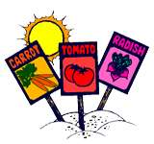
Name:______________________________
- What was the first food eaten my man?

- How many servings of vegetables a day does a person need?

- What is the definition of vegetable?

- Name the 8 types of vegetables.

- Name 2 types of seed vegetables.

- Define root vegetables and name 2.

- Name 3 tubers.

- Bulbs are part of two different vegetable systems – what are they?

- Name 2 stem vegetables.

- Name 2 types of leave vegetables

- Name 2 types of flower vegetables

- What are the fruit vegetables? Explain why tomatoes are sometimes called fruits instead of vegetables.

- Why should you NOT add baking soda to the vegetable cooking process?

